Adithya.J

230701013 CSE A

Exp No:12 File Organization Technique Single and two level directory

PROGRAM

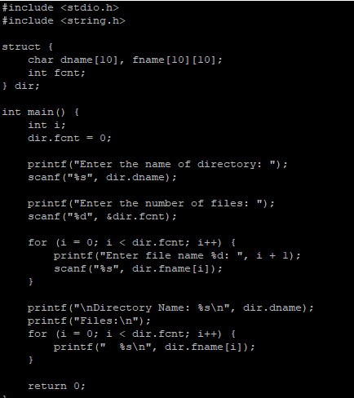

OUTPUT

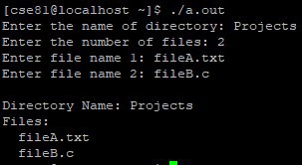

PROGRAM

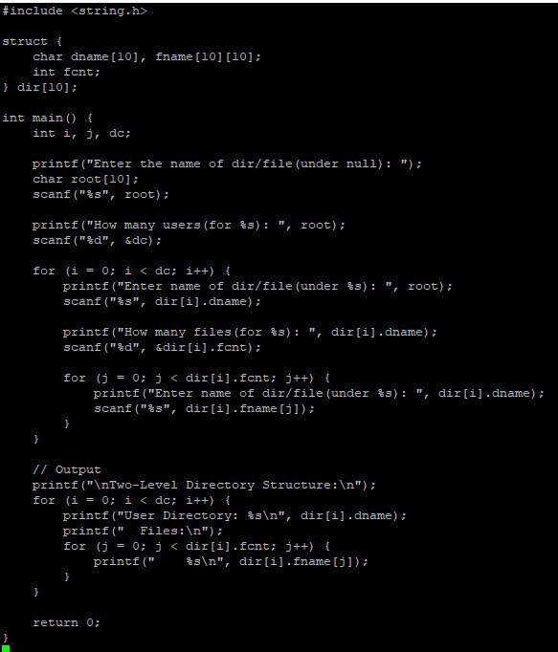

OUTPUT

